Rhetoric 101
Formal Essay Two: Peer Review
Check-List
2017

Directions

Fill out this form for each of your writers. Put the writer's name and your own name in the proper spaces provided. In addition to this form, EDIT the digital copy of the student's paper as well. Highlight any errors for the writer and send back with this form. You MUST send all copies of your forms to holguin2@illinois.edu on December 8th by midnight.

Your Name: Horris Feng

Name of Writer: Wency Wang

1. Does the thesis statement fall into any of the five weak thesis statement categories? If so, what is the problem and how would you fix it? Does the writer remind us of his or her thesis statement throughout the body paragraphs and the conclusion? Highlight these moments in the paper for the writer.

The thesis statement falls into the kind of weak thesis statement that it makes no claim.

The thesis statement is just an introduction of the procedure of the essay. I will fix it as the following sentence. It is quite interesting that Chinese and American advertisement campaigns for Coca Cola use different advertising strategies related to Collectivism and Individualism respectively because of distinct culture values.

Yes, she does remind us of his or her thesis statement throughout the body paragraphs and the conclusion.

2. Is Lin introduced with context and background on her argument? Is she referred to throughout this essay in an effective and consistent manner? Where does she need still need to be included? What paragraphs?

No, she is not introduced with enough context and background on her argument. More specific background or information is needed for the introduction of Lin. She is referred to throughout this essay in an effective way, but she is not referred to in a consistent manner. There is too less reference to Lin in this essay. She is needed in the end of the second paragraph, in the end of the third paragraph and at the beginning of the fourth paragraph.

3. Underline or highlight any mechanical/grammatical errors you notice in the essay. Write down the three most consistent problems you see in terms of the writer's style.

- Lack of ‘s’
- Use ‘his’ and ‘her’ mistakenly
- Lack of preposition

4. What structural or organisational problems do you see right now? How would you fix them?

The third paragraph is too long, and it should be divided into two paragraphs. (Marked by //) The introduction and conclusion are too short, more content including “so what” factor should be added to improve them.

5. What is the paper's topic? What are the primary sources? What would you like to know more about in terms of this writer's analysis of the primary sources?

The topic of this paper is the Chinese and American Coca Cola advertisement.

The primary sources are two videos (http://www.iqiyi.com/w_19rvf0nywl.html http://www.iqiyi.com/w_19rujqol9d.html) and two pictures shown as follow.

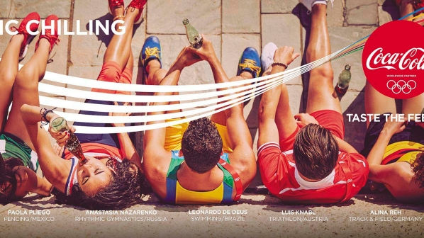

I want to know more about what causes the son’s guilty expression and what causes the mother’s disappointed expression in the third paragraph. Besides, I want to know more about what the video for American is related to under the statement that it has nothing to do with children-parents relationship in the third paragraph. What’s more, I also want to know more about how the people in the American poster seem strong in the fourth paragraph. Finally, I want to know how Lin’s statement paraphrased by the writer is relevant to writer’s own argument in the fifth paragraph.

6. What parts of the paper confused you? If you did not get confused, what aspects of the paper's argument do you disagree with?

I am confused about the relationship between brotherhood and individualism. In other words, I do not know how brotherhood is relevant to individualism.

7. Check the final draft directions. What does this writer still need to do to full fill all the basic requirement?

- Extend the paper to 6-7 pages
- More details on the description of the visual rhetoric
- Write a new relevant thesis statement
- Use Lin’s article more frequently
- Remove casual language
- Reveal the relationship between visual rhetoric and arguments more clearly
- Think of the importance of the topic and add “so what” factor in the introduction and conclusion
- Proofread the paper to minimize grammar and mechanics error

8. Final comments for your writer: create your own question and answer it.

Question: Are there any “so what” factor in this paper?

It seems that there are not “so what” factor in this paper. I cannot figure out how individualism and collectivism are important in American and Chinese advertisement campaign respectively.

